History : The Paper Plate Challenge

Hello and welcome from the History Department at Grays Convent High School.

We are sorry we cannot meet face to face at the moment, but we have put this task together for you to complete and bring it to school when you join us in September.

Your task is to be completed on a paper plate.
Either………..
You should pick either a famous dead person eg Queen Victoria or Martin Luther King and draw them on to the plate. It can be anybody you like or find inspirational. They need to have their name and the work should be nicely decorated.
Here are some examples
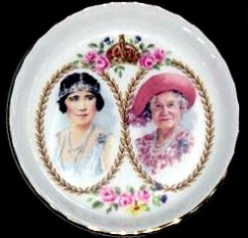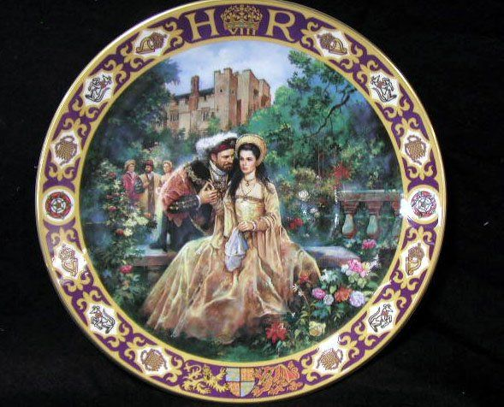

Your other choice is to pick a famous event to commemorate on a paper plate.
Here are a couple of examples………..
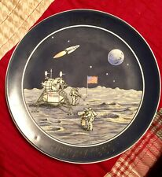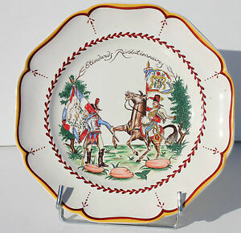
There will achievement points for every plate given to Mrs Smith in September

If you have not got a paper plate you may use the one below. You will need to print it out

