Geography Task : Geography Near You

Think about a journey you make most days.
It could be to a relative or a friend’s house, a shop, a school, a park, a church – you decide.
Let’s call the start of your journey A and the end of your journey B.
Write 9 points of your journey. What do you see? What do you hear? What can you smell?
You may use drawings or sketches as well as writing to help you in the shapes below.

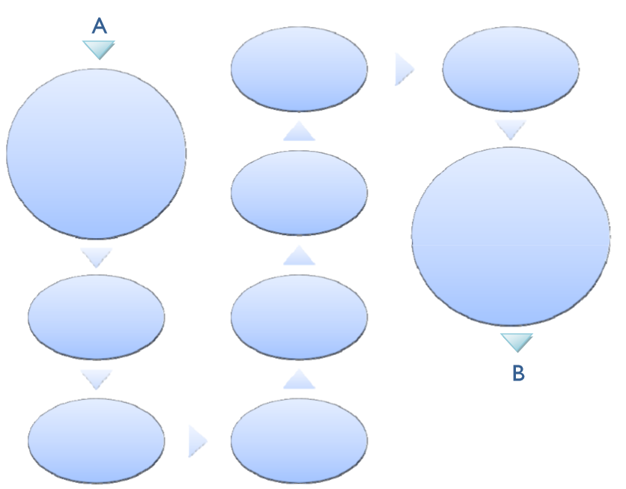

How brave are you?
In the box below draw a map of your journey.
Put on the streets you walk down, name them. Add buildings you pass. Can you add a compass? Label your map and annotate it if you can.

My Journey to

